**SRM Institute of Science and Technology**

**College of Engineering and Technology**

**B.Tech - Mechanical Engineering**

**Academic Year: 2022-23 Semester: 6 /Even Mark: 50**

**Subject Code: 18MEO113T Title: Design of Experiments Duration: 100 mins**

**Type of Test: CLA II**

| **Q. No.** | **Part A (10 x 1 = 10)** | **M** | **BL** | **CO** | **PO** | **PI** |
| --- | --- | --- | --- | --- | --- | --- |
| 1 | The natural variability of a process is measured by _____.   1. Sample standard deviation 2. Process standard deviation 3. Process mean 4. Sample mean | 1 | 1 | 1 | 3 | 3.1.6 |
| 2 | How many levels of a factor are recommended for a qualitative experiment?   1. one 2. two 3. three 4. three or more than three | 1 | 2 | 1 | 3 | 3.1.6 |
| 3 | What is presented in this diagram?     1. Mutual exclusivity 2. Cross-over effects 3. Main effects 4. Synergistic interactions | 1 | 1 | 1 | 3 | 4.1.4 |
| 4 | What plot describes average response values at all combinations of a process or design parameter settings?   1. Pareto 2. MPP 3. Main Effects 4. Cube plots | 1 | 2 | 1 | 3 | 4.3.4 |
| 5 | Strength of a machine - What Taguchi’s design would you plot for this?   1. Smaller the better 2. Larger the better 3. Nominal the better 4. Everything’s equal | 1 | 2 | 1 | 3 | 4.3.4 |
| 6 | What is the other name for nominal value?   1. confidence interval 2. probability limit 3. functional limit 4. probability limit | 1 | 1 | 1 | 3 | 3.1.6 |
| 7 | What does the NPP plot convey?   1. Normal distribution compliance 2. mean 3. variance 4. R2 value | 1 | 2 | 1 | 3 | 3.1.6 |
| 8 |  | 1 | 1 | 1 | 3 | 4.3.4 |
| 9 | ___________ occurs experimentation is done in a way to reduce bias.   1. Interaction 2. Error 3. Replication 4. Randomization | 1 | 2 | 1 | 3 | 4.3.4 |
| 10 | A formal way to seek the direction of minimum damage in optimisation process problems is called the _____________.   1. Tunneling 2. Localisation 3. Method of steepest descent 4. Method of steepest ascent | 1 | 1 | 1 | 3 | 4.3.4 |
|  |  |  |  |  |  |  |
|  | **Part B - Answer any 2 out of 3 (2 x 4 = 8 marks)** |  |  |  |  |  |
| 11 | What is a screening design? Why is it needed? Give one example. | 4 | 2 | 2 | 3 | 3.1.6 |
| 12 | Briefly discuss the experimenter’s role in the planning phase of DOE. | 4 | 3 | 2 | 3 | 4.1.4 |
| 13 | What is blocking? Explain with examples. | 4 | 3 | 2 | 3 | 4.1.4 |
|  |  |  |  |  |  |  |
|  | **Part C - Answer any 2 out of 3 (2 x 4 = 8 marks)** |  |  |  |  |  |
| 14 | What does this graph indicate? Discuss it. | 4 | 3 | 2 | 3 | 4.3.4 |
| 15 | Briefly discuss nominal-the-best Taguchi’s approach. | 4 | 2 | 2 | 3 | 4.3.4 |
| 16 | What is a robust design? Describe disturbances types briefly. | 4 | 2 | 2 | 3 | 3.1.6 |
|  |  |  |  |  |  |  |
|  | **Part D - Answer either of the choices in each question. (2 x 12 = 24 marks)** |  |  |  |  |  |
| 17 | **A**. Write in detail about the barriers in the effective application of DOE.  **OR**  **B.**  (i) What is Linear Regression? What are its types?  (ii)A sample of the various prices for a particular product has been conducted in 16 stores selected randomly in a city's neighbourhood. The following prices were noted:  95, 108, 97, 112, 99, 106, 105, 100, 99, 98, 104, 110, 107, 111, 103, 110.  Assuming that the prices of this product follow a normal law of variance of 25 and an unknown mean:  1. What is the distribution of the sample mean?  2. Determine the confidence interval at 95% for the population mean. | 12  6  6 | 3  4 | 2  2 | 3  3 | 3.1.6  4.1.4 |
| 18 | **A.** (i) What factors affect quality characteristics? Briefly discuss them.  (ii) Write about the input and output variability parameters in great detail.  **OR**  **B.** The following table gives the hardness values of 3 replicates of an L9 welding experiment with the aim of maximising hardness. There are 3 variables varied on 3 levels.  Voltage Current Wire-Speed H1 H2 H3  20 150 180 163.3 139.3 170.0  20 180 200 156.0 131.3 138.0  20 200 250 136.3 134.5 140.5  23 150 200 131.3 131.5 145.0  23 180 250 186.5 176.5 180.5  23 200 180 140.5 179.3 200.5  25 150 250 153.5 145.5 140.5  25 180 180 180.5 170.5 190.5  25 200 200 190.0 174.5 180.0  Calculate  (i) Main effects for all levels of all factors.  (ii) Draw the main effects plots  (iii) Identify which combination gives the maximum hardness.  (iv) State which Taguchi’s function is appropriate for this problem. | 5  +  8  7  3  1  1 | 3  4 | 3  3 | 2  2 | 3.1.6  4.3.4 |

**Prepared by: DSS**

**Outcome Alignment Matrix:**

| QUESTION  NUMBER | CO distribution | | | | |
| --- | --- | --- | --- | --- | --- |
| CO1 | CO2 | CO3 | CO4 | CO5 |
| 1 |  | x |  |  |  |
| 2 |  | x |  |  |  |
| 3 |  | x |  |  |  |
| 4 |  | x |  |  |  |
| 5 |  | x |  |  |  |
| 6 |  |  | x |  |  |
| 7 |  |  | x |  |  |
| 8 |  |  | x |  |  |
| 9 |  |  | x |  |  |
| 10 |  |  | x |  |  |
| 11 |  | x |  |  |  |
| 12 |  | x |  |  |  |
| 13 |  | x |  |  |  |
| 14 |  |  | x |  |  |
| 15 |  |  | x |  |  |
| 16 |  |  | x |  |  |
| 17A |  | x |  |  |  |
| 17B |  | x |  |  |  |
| 18A |  |  | x |  |  |
| 18B |  |  | x |  |  |
| **Total** |  |  |  |  |  |
| **%** |  | **50%** | **50%** |  |  |

“**Quality Matrix**”:

| **Question No.** | **BL Distribution** | | | |
| --- | --- | --- | --- | --- |
| **L1** | **L2** | **L3** | **L4** |
| 1 | x |  |  |  |
| 2 |  | x |  |  |
| 3 | x |  |  |  |
| 4 |  | x |  |  |
| 5 | x |  |  |  |
| 6 |  | x |  |  |
| 7 | x |  |  |  |
| 8 |  | x |  |  |
| 9 | x |  |  |  |
| 10 |  | x |  |  |
| 11 |  | x |  |  |
| 12 |  |  | x |  |
| 13 |  |  | x |  |
| 14 |  |  | x |  |
| 15 |  | x |  |  |
| 16 |  | x |  |  |
| 17A |  |  | x |  |
| 17B |  |  |  | x |
| 18A |  |  | x |  |
| 18B |  |  |  | x |
| **Total** |  |  |  |  |
| **%** |  |  |  |  |

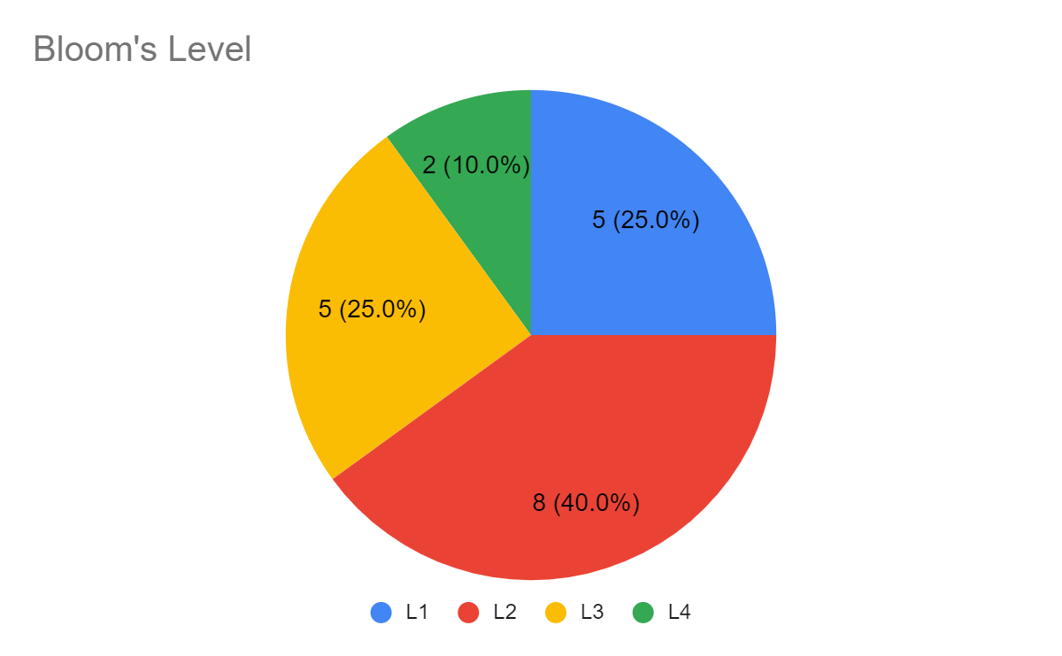

Prepared by and Course Coordinator

(Deborah Serenade Stephen)